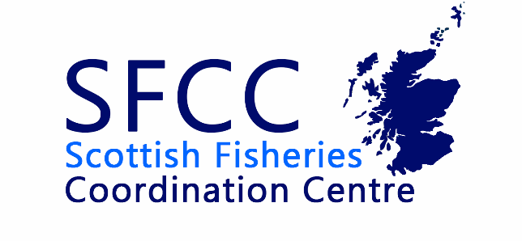
SFCC Management Committee Meeting

30th November 2022

Minutes

Welcome and apologies for absence
Marcus Walters – Deveron, Bogie & Isla Rivers Charitable Trust (Chair)
Alan Wells – Fisheries Management Scotland
James Hunt – The Tweed Foundation
Joanna Girvan – Forth Rivers Trust
John Armstrong – Marine Scotland Science
Kjersti Birkland – SEPA
Leanne Munro – Scottish Fisheries Coordination Centre/Kyle of Sutherland Fisheries Trust
Rowan McCleary – Galloway Fisheries Trust
Sean Robertson – Scottish Fisheries Coordination Centre

Apologies
Antje Branding – Marine Scotland

Minutes of previous meeting, review of action points and matters arising

Management Committee 14th September 2022
ACTION: Sean & Leanne to share with committee some options for costing the electrofishing courses.
Leanne shared a costing document of the electrofishing courses which outlined different profit margins as well as offering various SFCC member discount percentages.
ACTION: SR to trial use of 4G at Faskally to see if it is possible to use to host a Teams meeting.

Staff Report from Sean & Leanne
Update over the last two months of work. The training courses delivered to members as well as the National projects involved and the support delivered to members.
JH – Catchment evidence base forum, the platform (hub) they use all data that is relevant to fisheries stored and is it something SFCC could implement so members can access all data in their catchment.
AW – it means the data that we collect should be available in the same way.
A desire to be a ‘Team Scotland’ approach for the implementation/wild salmon strategy plan. Could SFCC be a starting point to sharing data widely? Need to discuss with the wider membership for their views - Biologists meeting the place to first suggest this?
Sean – to confirm whether they need to do the ARMI course to update the riverfly database

2023 Biologists Meeting – Venues & Themes
A workshop on day 2 to encourage in-person attendance.
Run through the draft programme of the biologists meeting.
Sean/Alan to discuss with Antje about the wild salmon strategy: implementation plan session and whether material will be ready by then.
SEPA partnership – e.g. the hydrology department and the benefits of it. Rowan to do a talk or to ask if they could do a talk?
Long-term availability of all data for the catchments. Building back after SEPA cyber attack to make their data available to fisheries managers.
Sean to ask if UHI would do a talk on the SALMOVE project or invite them generally.
NEPS report to be published – Sean to ask Iain Malcom but perhaps to wait.
River Laxford talk – Restoration Session?
Nutrients additions – Neil/Fionn John to contact them about a talk.
Two parts to the River Garry talk

Financial matters

Cashflow report
Documents were circulated in advance of the meeting

Invertebrate training
Online material to act as a supplement to the in-person invertebrate training. Sean shared the material that Craig Sommerville have produced for the online material. Sean has requested to ask SFCC to contribute from the reserves towards the development of the online material. FMS will also make a significant contribution to the cost of this.

AOB
Leanne thanked the committee for their support during her time at SFCC.

