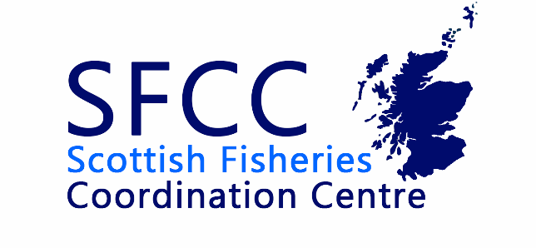
SFCC Management Committee Meeting

17th May 2023

10:00 – 12:00

Minutes

Welcome and apologies for absence

Marcus Walters – Deveron, Bogie & Isla Rivers Charitable Trust (Chair)
Kjersti Birkland – SEPA
Ante Branding – Marine Scotland
Joanna Girvan – Forth Rivers Trust
James Hunt – The Tweed Foundation
Rowan McCleary – Galloway Fisheries Trust
Sean Robertson – Scottish Fisheries Coordination Centre
Alan Wells – Fisheries Management Scotland
Ruth Watts – Beauly District Salmon Fishery Board

Apologies
John Armstrong – Marine Scotland Science

Minutes of previous meeting, review of action points and matters arising

Management Committee 30th May 2022
All actions from the previous meeting in November had been resolved.
Discussion around the availability of ecological and chemical data from SEPA was raised. Data which has been obtained has no metadata which makes interpretation of that data extremely difficult. A portal where its easy to understand what data is being collected in what locations would be advantageous.
The question of funding for the National Electrofishing Programme for Scotland was raised. At present, Scottish Government budgets have not been set and funding for these projects is uncertain. However, AB confirmed that she would send an update as soon as the information is available.

Staff Report from Sean

November – May Update
Sean delivered a presentation on SFCC’s activities since the last meeting. This included work on the annual conference, Fisheries Management Plans, meetings in relation to GIS and discussions with the EA and NRW about expanding the pink salmon app into England and Wales. In terms of training there had been an Introduction to R course, Train the Trainer, the SFCC Invertebrate Protocol and discussions with NatureScot about more courses for the working with rivers scheme. Sean also gave an overview of some of the member support and outreach which has bene ongoing.
The question of what phase 2 of the Fishery Management Plan project would entail was raised. This is detailed in the Project Overview document, Sean to recirculate. There will also be an element of reviewing phase 1 before moving into phase 2. In terms of timelines, in the application we specified the end of 2023 to have work completed by contributing boards and trusts., We aimed to get as much time as possible, as once summer sampling season begins many boards and trusts will be extremely busy, especially if NEPS goes ahead.
The status of the plans completed during stage 1 was also discussed. As these are ‘stand-alone’ products it was agreed that the option to make these public now should be available to all areas, accepting that some may prefer to complete the entire process (including any outstanding consultation with stakeholders, prior to publication.
ACTION: Sean to make a public facing link to all plans available to contributors directly.
AB noted that both the SFCC and FMS conferences were well attended, and officials have updated Ministers on their success. Having the videos from the conferences available online is a great resource for the Scottish Government.

Availability of SFCC Protocols
SFCC has received queries from consultancies in regards to access to the SFCC sea lice sampling protocol. It was noted that many other organisations (CIEEM, NatureScot, Bat Conservation Trust) have made protocols freely available. It was proposed that SFCC should adopt the same approach for agreed protocols, while keeping training materials to SFCC members and those who have paid to go on training courses.
There was a discussion about whether making protocols freely available might act as a disincentive for attendance at formal training courses. A clear distinction was drawn between training materials, provided as a resource as part of attendance at SFCC training courses, and protocols, which set out the standardised process that should be followed when undertaking the work (and therefore don’t directly relate to competence). It was agreed that approval would be sought from the management committee before making protocols available online. It was also noted that some protocols are not currently associated with specific training courses (e.g. sea lie sampling). If such protocols are not made available, it could result in other methodologies being developed, possibly resulting in inconsistent data. The inclusion of specific language emphasising the need for specific training as part of using the protocol, would also be explored. In the case of electrofishing training, this could cover the need for there to be at least one person who is a qualified electrofishing team leader, and at least one other qualified member of staff.
The interpretation of fisheries data was also discussed in the context of appropriate survey design and data analysis. This is common concern when SFCC members receive requests for data pertaining to specific developments within catchments.
It was agreed that SFCC protocols would be made available online, but training manuals and other materials associated with courses would not be made available to those who have not undertaken the relevant course.

Financial matters

Cashflow report
Sean discussed the cashflow report and highlighted some areas of additional expenditure since, the last meeting, most notably a new, more capable laptop for GIS image analysis. Most SFCC member subscriptions have not been paid.

AOB

SFCC used to hold data on a Marine Scotland server associated with the previous manager’s marlab.ac.uk account. As files have been transferred over to a new system, Sean does not currently have access to this historic information. however there may be useful records and presentations stored on the Scottish Government system. As MS Policy and Science are becoming the Marine Directorate, it was agreed that any historic information should be identified and transferred onto the SFCC systems ASAP.
ACTION: Sean to investigate whether access to SFCC files on the old server can be obtained.
An update on access to OS maps was requested. This had stalled, due to liability clauses in the licensing documents. Sean to revive efforts.
ACTION: Sean to further examine the possibility of gaining access to OS maps through the Public Sector Geospatial Agreement (PSGA).

